The following are descriptions of the maps made from each column in the provided EPA data.

Drum locations  (no symbolization, raw data)  - There are 138 data points | 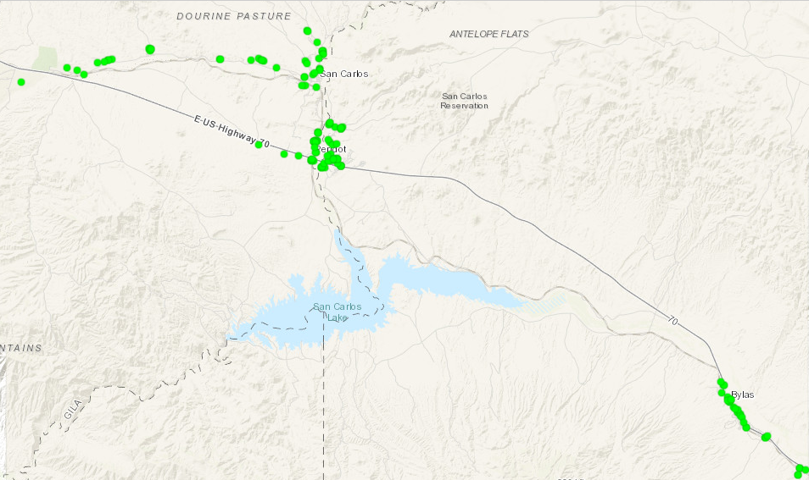
Heatmap of density of drum locations  - There appears to be clusters (3+) of points that may be worth looking at separately  - San Carlos, West  - San Carlos, East  - Peridot  - Pueblo Valley  - ... | 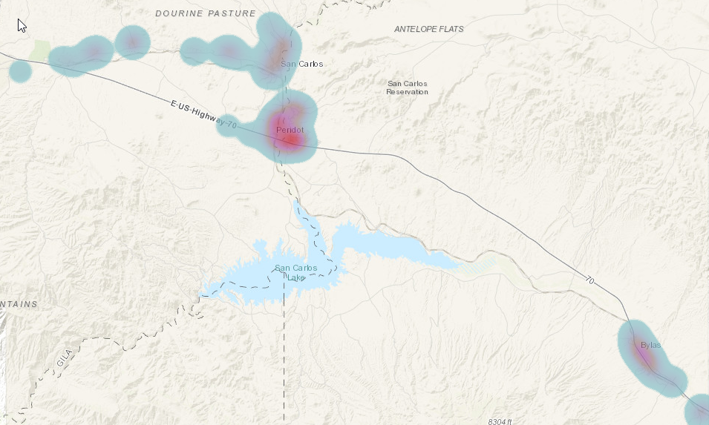
Access Agreement  (Yes, No, Unknown)  - This likely refers to if the location had given permission for access beforehand  - Majority was Yes (131)  - Unknowns (7) were more public areas (ie parks, dumps, community health centers) | 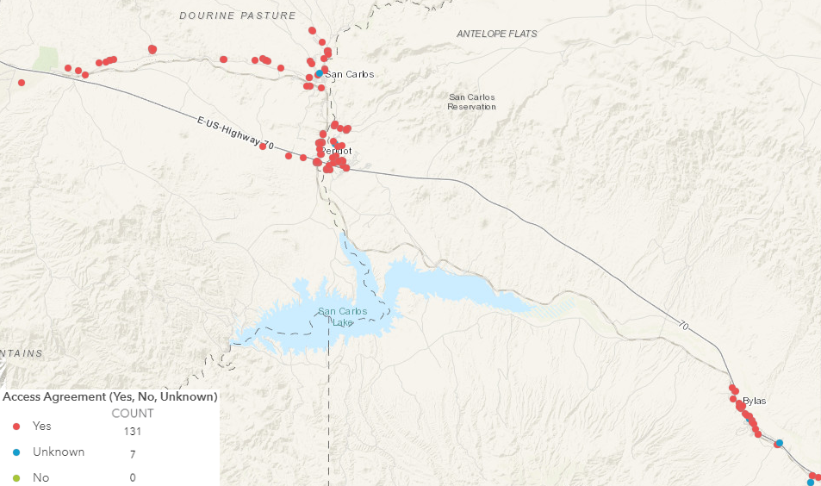
AccessIssues  (can be used for margin of error info, table needs cleaning)  - Table shows it could use cleaning to reduce categories…  - None  - Dogs  - Buried  - Other | 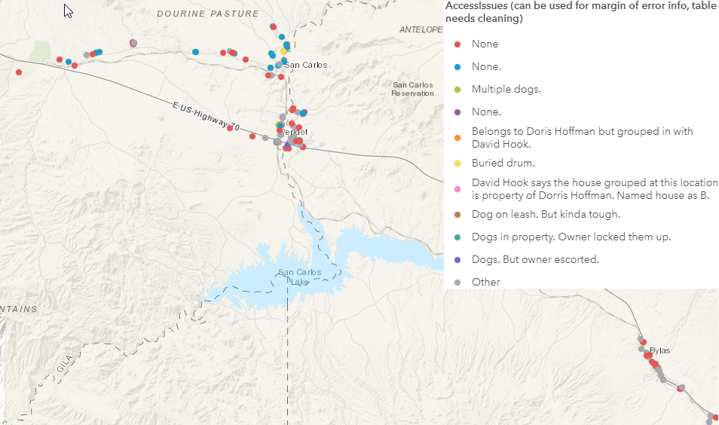
Drum Type  (steel/metal, plastic/poly, other, needs minor cleaning)  - All were ‘Steel’ (137) but one | 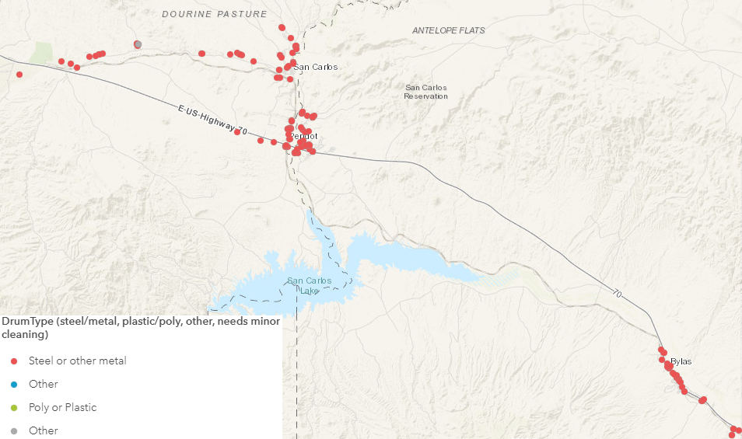
Refuse In Drum  (Yes, No, Unknown, Other)  - This varies on the overall scale. It may be interesting to look at specific clusters in detail. | 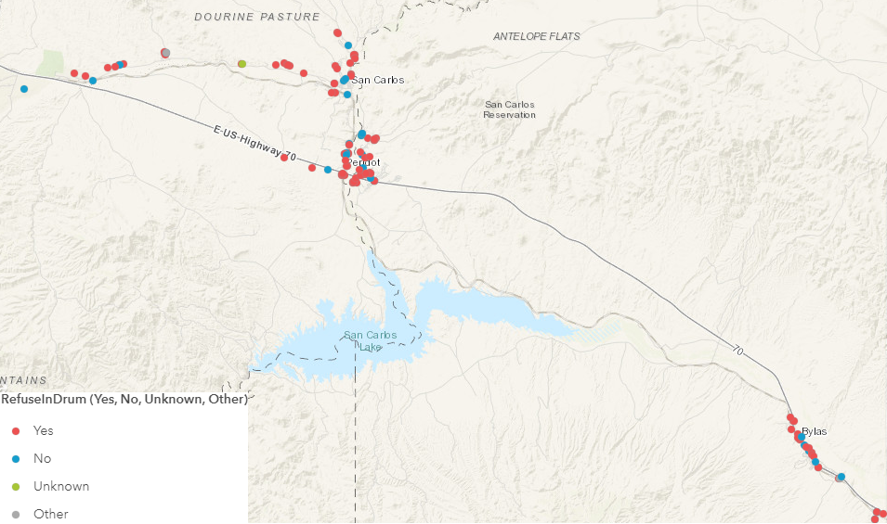
Other Waste  (Yes, No, Unknown, Other)  - This varies on the overall scale. This also may be interesting to look at specific clusters in detail. | 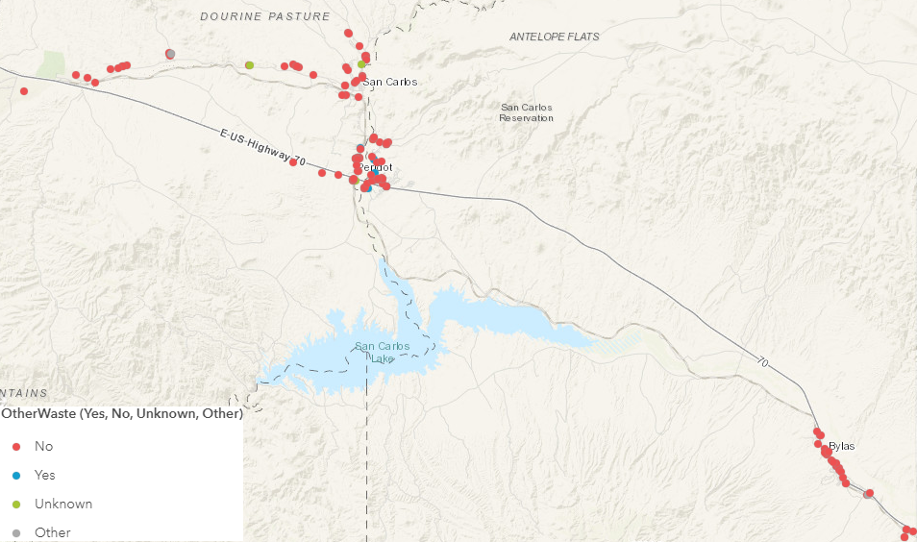
DrumRemoved  (Yes, No, Unknown, Other, labeled with comments)  - Most were removed (134)  - Comments mainly detail the number and type of drum(s) | 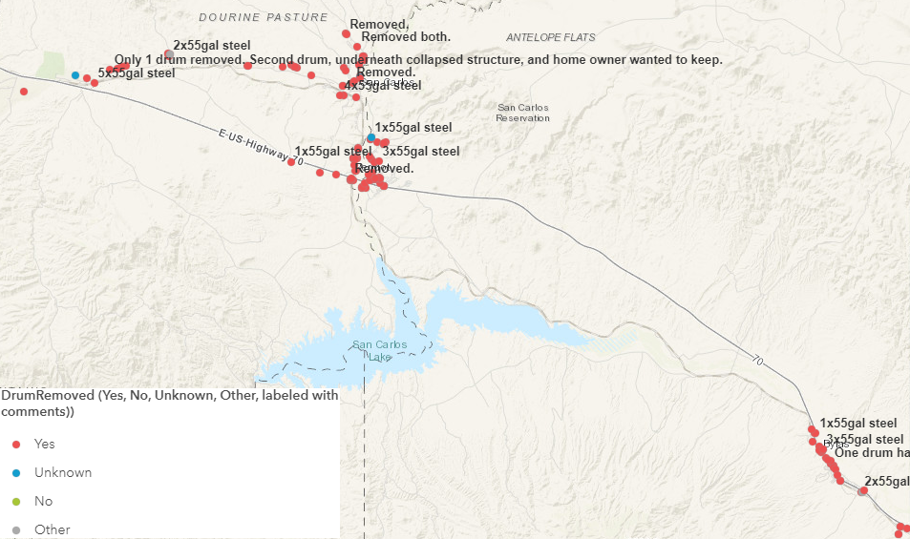
DrumReplaced  (Yes, No, Unknown, labeled with comments)  - Answers varied, but not sure if this is worth exploring further  - No (106)  - Yes (19)  - Unknown (12)  - Other (1) | 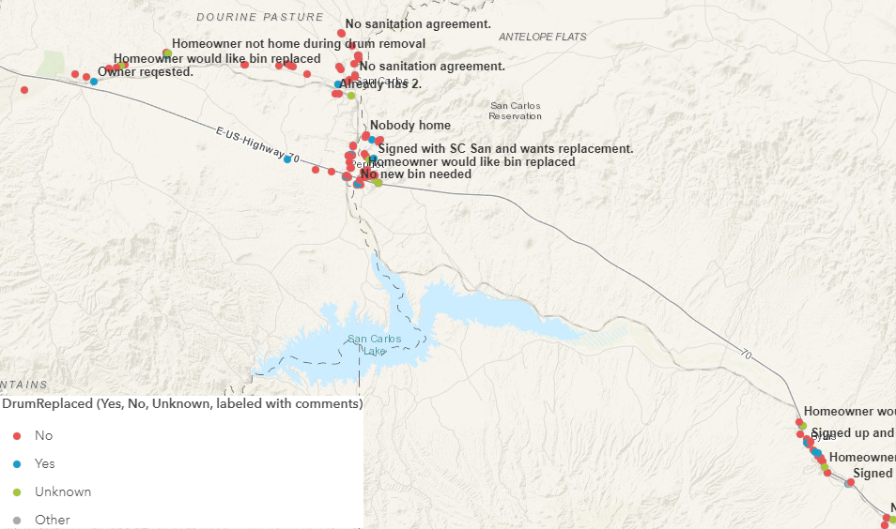
SampleCollected  (Yes, No, Unknown, labeled with SampleID)  - Answers varied, possibly interesting to explore why  - Yes (104)  - No (22)  - Unknown (12) | 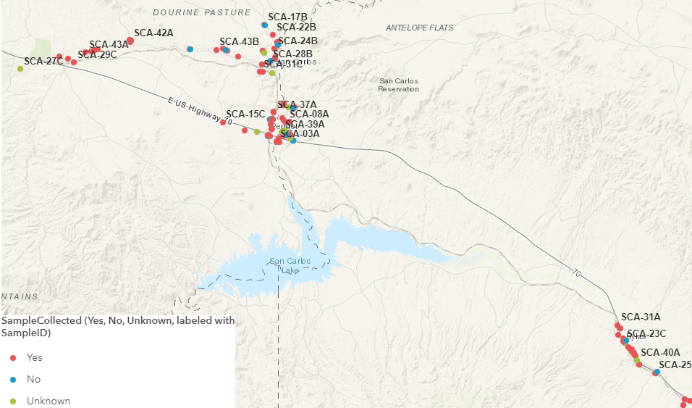
SampleAnalyses  (labeled with SampleID)  - Answers varied, need to review what this means, possibly interesting to explore further  - Standard (87)  - Standard+10/20% (12)  - Standard+20% (9)  - Standard+10% (4)  - Other (26) | 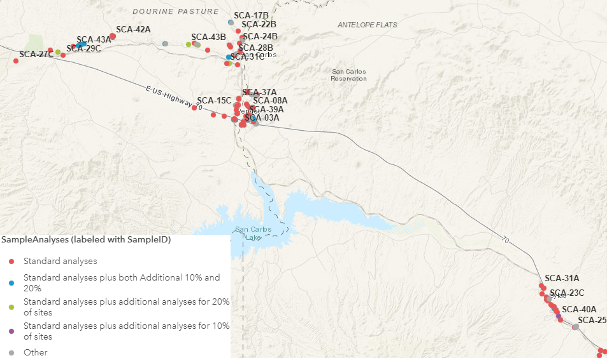
QAQCSample  (Yes, No, Unknown)  - Answers varied, need to review what this means, possibly interesting to explore patterns  - No (113)  - Yes (16)  - Unknown (9) | 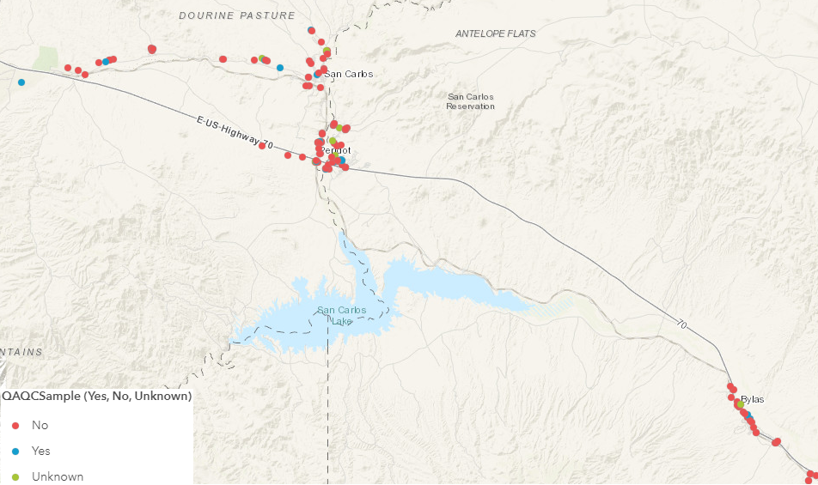
DrumCount (as graduated points) | 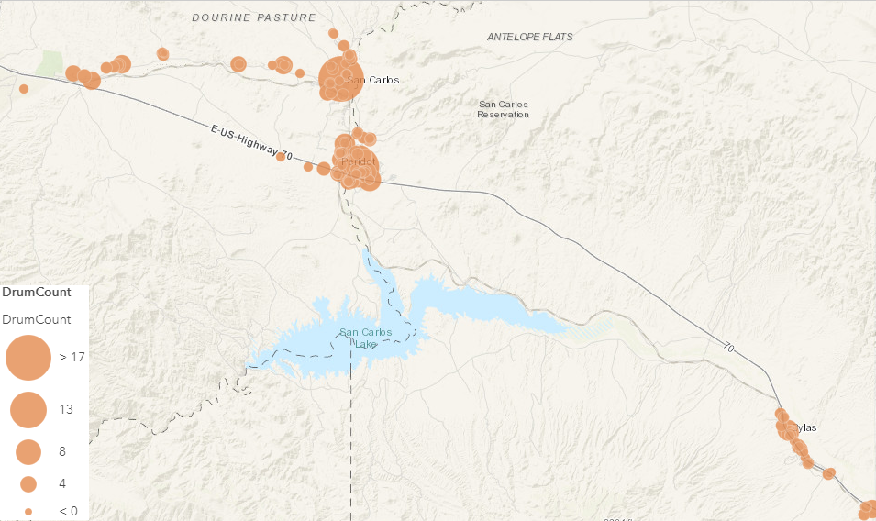
DrumCount (as a heatmap)  - This seems like a better way to present the data, may be worth exploring further | 